Data Structure and Algorithm

Laboratory Activity No. 1

Object-oriented Programming

|  |  |
| --- | --- |
| *Submitted by:* | *Instructor:* |
| Polestico,Paul Justine D. | Engr. Maria Rizette H. Sayo |

July, 26, 2025

# Objectives

This laboratory activity aims to implement the principles and techniques in object-oriented programming specifically through:

* Identifying object-orientation design goals
* Identifying the relevance of design pattern to software development

# Methods

* Software Development
  + The design steps in object-oriented programming
  + Coding style and implementation using Python
  + Testing and Debugging
  + Reinforcement of below exercises
  1. Suppose you are on the design team for a new e-book reader. What are the primary classes and methods that the Python software for your reader will need? You should include an inheritance diagram for this code, but you do not need to write any actual code. Your software architecture should at least include ways for customers to buy new books, view their list of purchased books, and read their purchased books.
  2. Write a Python class, Polygons that has three instance variables of type str, int, and float, that respectively represent the name of the polygon, its number of sides, and its area. Your class must include a constructor method that initializes each variable to an appropriate value, and your class should include methods for setting the value of each type and retrieving the value of each type.

# Results

Present the visualized procedures done. Also present the results with corresponding data visualizations such as graphs, charts, tables, or image . Please provide insights, commentaries, or explanations regarding the data. If an explanation requires the support of literature such as academic journals, books, magazines, reports, or web articles please cite and reference them using the IEEE format.

Please take note of the styles on the style ribbon as these would serve as the style format of this laboratory report. The body style is Times New Roman size 12, line spacing: 1.5. Body text should be in Justified alignment, while captions should be center-aligned. Images should be readable and include captions. Please refer to the sample below:

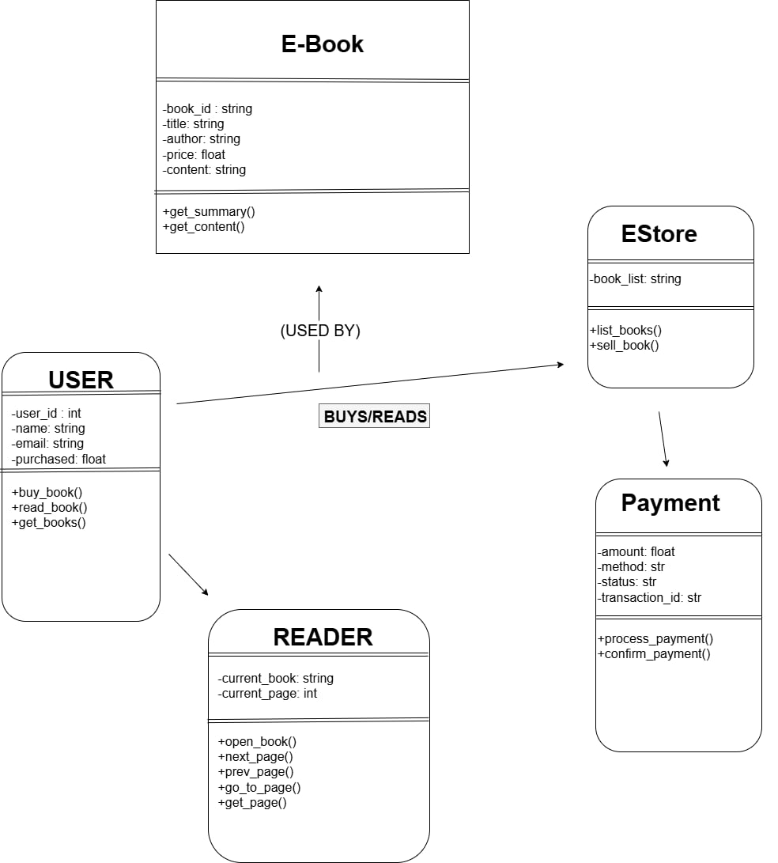

Figure 1 Diagram of the E-Book Reader

If an image is taken from another literature or intellectual property, please cite them accordingly in the caption. Always keep in mind the Honor Code [1] of our course to prevent failure due to academic dishonesty.

# Conclusion

The conclusion expresses the summary of the whole laboratory report as perceived by the authors of the report.

**References**

[1] Co Arthur O.. “University of Caloocan City Computer Engineering Department Honor Code,” UCC-CpE Departmental Policies, 2020.

“Create UML class diagrams” draw.io

<https://www.drawio.com/blog/uml-class-diagrams> (accessed July 26,2025).